**MycoTechnology’s ClearHT™ natural flavor modifier achieves FEMA GRAS status**

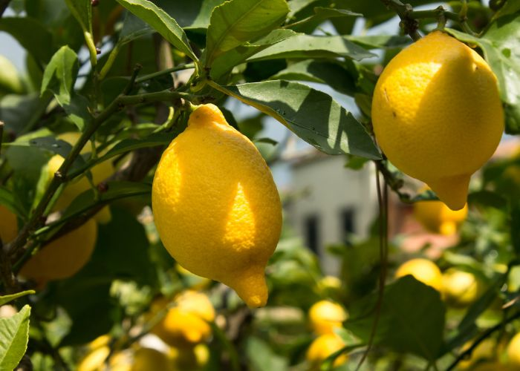

*ClearHT™ natural flavor enhances flavors such as citrus and caramel, and offers new ways to modulate sweetness, helping to address* [*consumer demand*](https://myco-technology.prezly.com/new-consumer-research-reveals-widespread-demand-for-new-naturally-derived-sugar-alternatives) *for better-tasting, healthier products.*  
*(Photo Credit: Getty Images)*

**April 8, 2025**

MycoTechnology, Inc., has announced that its new [ClearHT™ natural flavor](https://www.mycoiq.com/ingredients/clear-ht/) has received Generally Recognized As Safe (GRAS) status from the Flavor and Extract Manufacturers Association (FEMA) for use as a flavor with modifying properties (FMP) in multiple food and beverage categories.

Discovered from the honey truffle, a unique species of fungi with a rich history of use, ClearHT™ natural flavor is the newest addition to MycoTechnology’s portfolio of innovative taste solutions. At low inclusion levels, it enhances flavors such as citrus and caramel, and offers new ways to modulate sweetness, helping to address continued consumer demand for better-tasting, healthier products. It will be available for use in markets that recognize FEMA GRAS determinations by early 2026.

“Achieving FEMA GRAS status affirms the safety of ClearHT™ natural flavor and opens new opportunities in many regions,” says Sue Potter, Ph.D., Vice President, Global Regulatory Affairs at MycoTechnology. “This is a significant milestone in our efforts to expand the availability of our ingredient solutions to global markets.”

Jordi Ferre, MycoTechnology’s CEO, adds, “We are proud to introduce ClearHT™ natural flavor, our latest innovation in MycoTechnology’s line of transformative ingredient solutions. Our team has continued to demonstrate exceptional progress in scale-up, safety validation, and applications development in preparation for commercial availability. This approval marks another important step in our mission to promote healthier, better-tasting food and beverages.”

**About MycoTechnology, Inc.**

Established in 2013 and based in Aurora, Colorado, MycoTechnology fuses nature, science, and culinary innovation to deliver value-added ingredients for healthier, better-tasting and more sustainable food. Harnessing the power of fungi with its advanced fermentation technology, Myco targets the industry’s most pervasive challenges to transform the future of food. With $220M raised so far from prominent investors across different sectors, MycoTechnology has created a sustainable, state-of-the-art, 86,000 sq ft facility, producing innovative ingredients via mushroom mycelial fermentation. Its award-winning flavor modifier, ClearIQ™ natural flavor, is sold globally to major flavor houses, co-manufacturers, distributors and CPG firms. MycoTechnology continues to uncover new solutions from fungi, including its latest discoveries, ClearHT™ natural flavor and honey truffle sweet protein. Collectively, these products offer new ways to address complex food system challenges around the globe and increase the availability of delicious, nutritious, clean-label foods. Leveraging their powerful technology and the intelligence of nature, Myco pursues ongoing discovery and innovation for the food industry and beyond.